Wyke Regis and Lanehouse Medical Practice

More information:

For more information about keeping your records safe and secure, you will find a helpful leaflet produced by the NHS:

http://www.nhs.uk/NHSEngland/thenhs/records/healthrecords/Documents/PatientGuidanceBooklet.pdf

**To apply & register**

You may have already signed up to other online services, but due to the highly confidential nature of this service, we require all patients to bring their ID to be validated.

You will need to visit the surgery with the application form completed, and two documents: one showing proof of your address and the other being an item of photo ID.

The reception team will forward the application to a member of the clinical team for approval and if agreed you will normally be able to view your records within 14 working days.

Please note that clinical work always takes priority over admin such as this, so please bear with us if it takes a little longer.

Online Access to Medical Records

Patient Leaflet

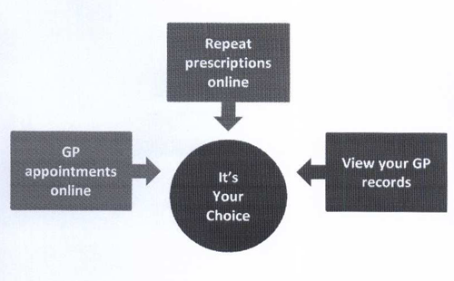



**Before you apply for online access to your record, there are some other things to consider.**

Although the chances of these things happening are very small, you will be asked that you have read and understood the following before you are given login details

**Things to consider**

**Forgotten history** There may be something you have forgotten about in your medical record that you might find upsetting

**Choosing to share information with someone** It’s up to you whether or not you share your information with others, It’s your choice, but also your responsibility to keep the information safe and secure.

**Coercion** If you think you may be pressured into revealing details from your patient record to someone else against your will, it is best you do not register for access at this time

**Misunderstood information** Your medical record is designed to be used by clinical professionals to ensure that you receive the best possible care. Some of the information within your medical record may be highly technical, written by specialists and not easily understood. If you require further clarification, please contact the surgery for a clearer explanation.

**Information about someone else** If you spot something in the record that is not about you or notice any other errors, please log out of the system immediately and contact the Practice as soon as possible

**It will be your responsibility to keep your login details and password safe and secure.**

**If you know or suspect that your record has been accessed by someone that you have not agreed should see it, then you should change your password immediately.**

**If you can’t do this for some reason, we recommend that you contact the practice so that they can remove online access until you are able to reset your password.**

**If you print out any information from your record, it is also your responsibility to keep this secure. If you are at all worried about keeping printed copies safe, we recommend that you do not make copies at all.**

**Abnormal results or bad news**

If your GP has given you access to test results or letters, you may see something that you find upsetting to you. This may occur before you have spoken to your doctor or while the surgery is closed, and you cannot contact them.

**Online Services Records Access Patient information leaflet.**

If you wish to, you can now use the internet to book appointments with a GP/Clinical Practitioner, request repeat prescriptions for any medication you take regularly and look at your medical record online. You can also still use the telephone or call in to the surgery for any of these services as well. It’s your choice.

Being able to see your record online might help you to manage your medical conditions. It also means that you can access your records from anywhere in the world should you require medical treatment whilst on holiday.

If you decide not to join or wish to withdraw, this is your choice and the Practice staff will continue to treat you in the same way as before.

You will be given login details, so you will need to think of a password which is unique to you. This will ensure that only you are able to access your record (unless you choose to share your details with a family member or carer)

